


CARE CENTRE BRINGS FESTIVE CHEER TO ALSAGER WITH CHRISTMAS TREE SPONSORSHIP

Residents and team members of Twyford House Care Home visited the tree on the Civic Green in Alsager town centre ahead of the annual lights switch-on.
Twyford House Care Home first sponsored the Christmas tree in 2020, the same year that the luxury care home opened its doors for the first time.
Situated in Richard Woodcock Way, in the heart of Alsager, Twyford House is a spacious and elegant care setting offering exceptional residential, memory and respite care for adults.
The care home is part of the Lovett Care Limited which has operated care homes for over a decade and has a strong reputation in the care industry.
Laura Lockett, General Manager at Twyford House, said:
“We’re so excited to be sponsoring the Alsager Christmas Tree for a second year!
"The tree has brought so much cheer to our residents who are very proud of the sponsorship. We hope it brings cheer to the residents of Alsager too.”
Craig Cook, Chief Executive Officer at Lovett Care, added:
“Sponsoring the Alsager Christmas tree represents our ongoing commitment to supporting the Alsager community.
"We’re delighted to sponsor the tree for a second year running, and we hope it brings joy to the town."

.
Chair of Alsager Town Council, Michael Unett, thanked Lovett Care for sponsoring the tree, saying: “We are grateful once more to Lovett Care for their financial support which helps our community to celebrate the festive season.
"It was a pleasure to see the community enjoy the Christmas lights switch-on at the weekend.”

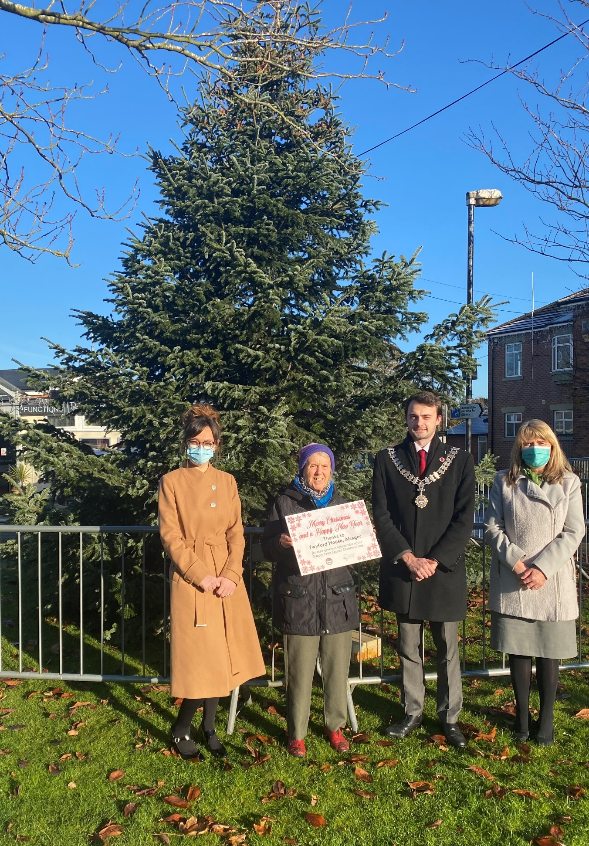
L-R: Laura Lockett (General Manager at Twyford House Care Home), Pearl Maries (Resident at Twyford House), Michael Unett (Chair of Alsager Town Council), and Dawn Jones (Front of House Manager at Twyford House)

-- ENDS --
Twyford House Care Home offers exceptional person-centred residential, dementia, respite and day care for adults within a vibrant and inclusive community. To find out more about Twyford House Care Home, visit: https://www.lovettcare.co.uk/twyford-house/, call: 01270 323443 or email: enquiries.twyford@lovett-care.com

